**Information about the Time Table Generation Software**

Files inside Time Table Folder:

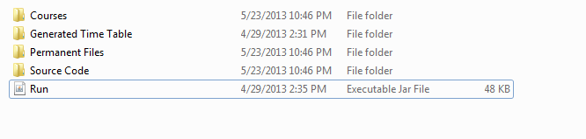

There are 4 folders and one executable file in ‘ Time Table’ folder.

1. Courses: It contains all the courses. Each of the course has an excel file for it which contains all the students enrolled in the course.
2. Generated Time Table Folder contains the time table which will be generated once we have finished using the program.
3. Permanent Files contains two excel files; first file has names of professors. Second excel file has names of available rooms in the department.
4. Source Code contains the project code which can be loaded in Software like Net Beans or Eclipse. Once loaded, the time table generation program can be modified as needed.

**Run is the executable file using which Time Table is generated.** Once we open the ‘Run’ executable file, Time Table Generation software starts.

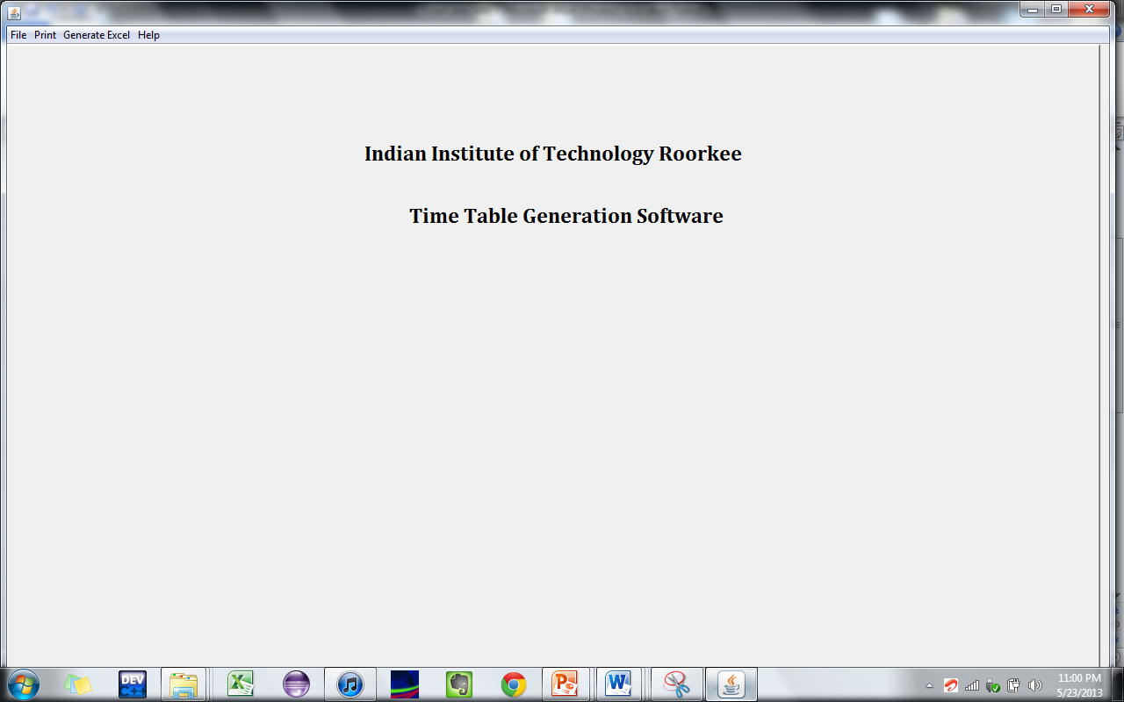

File has four options:

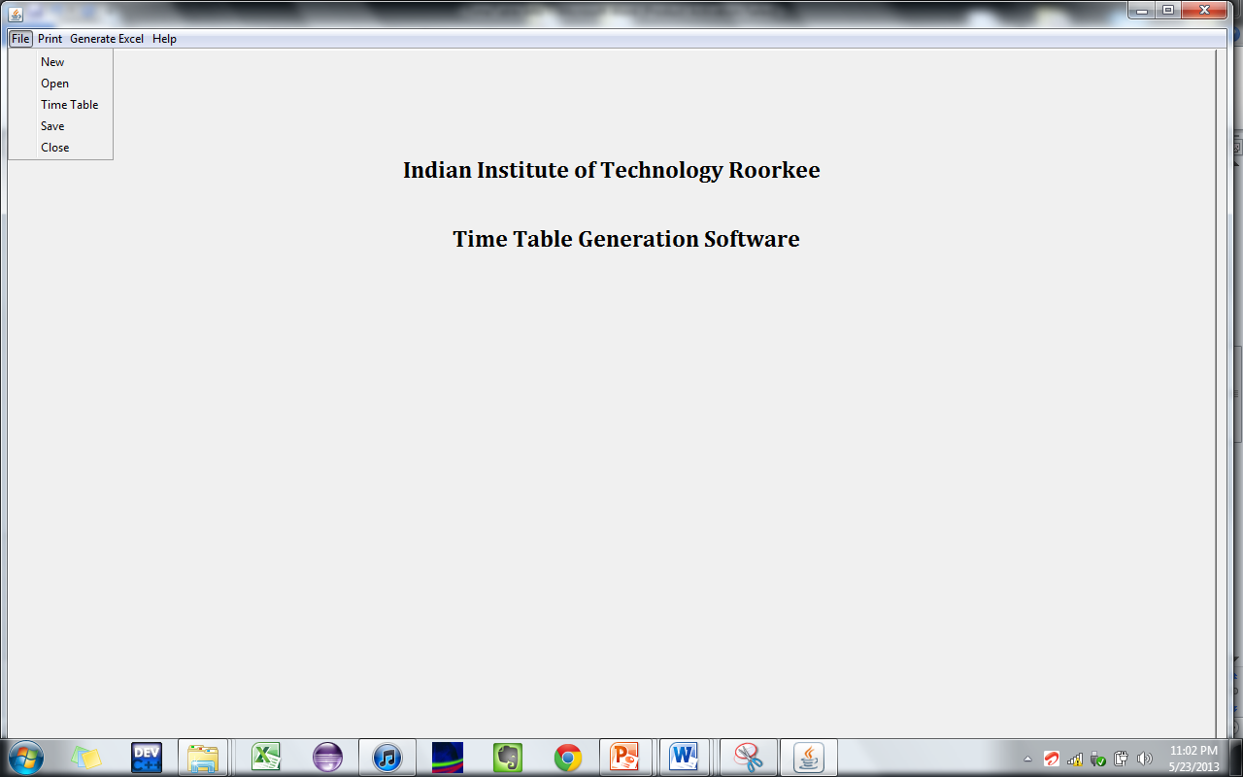

1. ‘New’ is used to create a new time table.
2. ‘Open’ is used to load a semi - finished time table, which was saved before using the
3. ‘Save’ option.
4. ‘Time Table’ is used to go back to home screen of time table generation software.
5. ‘Close’ is used to close the program.

When we click on ‘New’ (5) following screen appears:

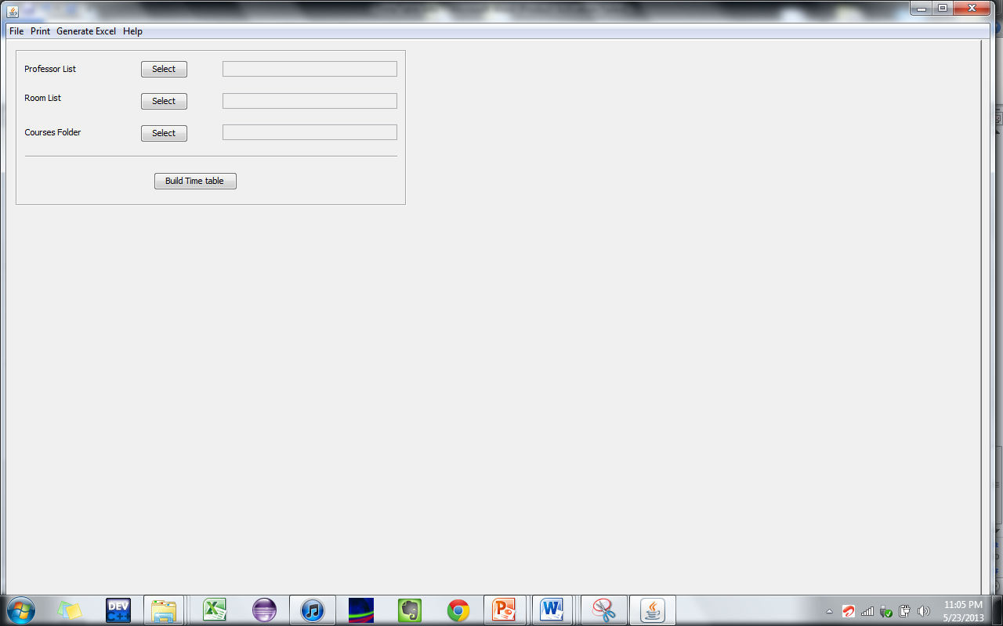

In order to start time table generation process, we must feed the information regarding professors, available rooms and Courses that are to be scheduled in the time table.

We load the professor information and Room List from excel files located inside ‘Permanent Files’(3) folder.

In order to load the course information, we select the ‘Course’ folder.

Once we have selected the three paths, we click on ‘Build Time Table’.

The following screen appears:

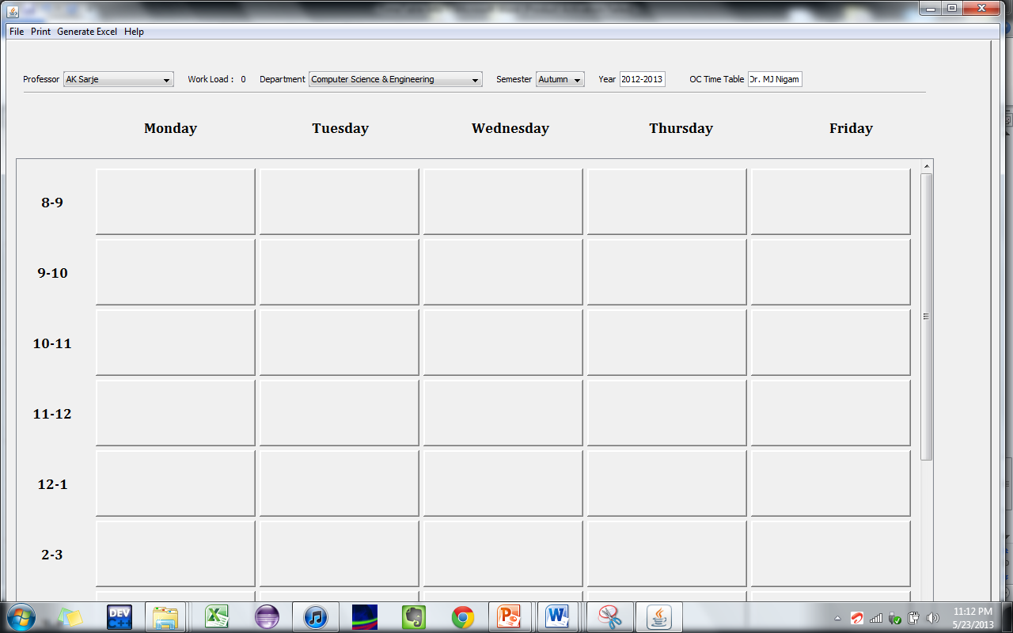

13

15

14

12

11

10

In the above screen,

1. Is used to select the name of the professor for whom the time table is being built.
2. Work Load is dynamically generated depending on how many hours work is assigned to professor in a week.
3. Used to select the Department.
4. Used to select the semester.
5. Used to enter the academic year.
6. Name of the O.C. Time Table.

In the above screen, we can double click on any of the time slots and assign a class for the professor in it. If there are some clashes then a pop up window will notify the user about it.

For example if we double click on the first time slot, the following screen appears:

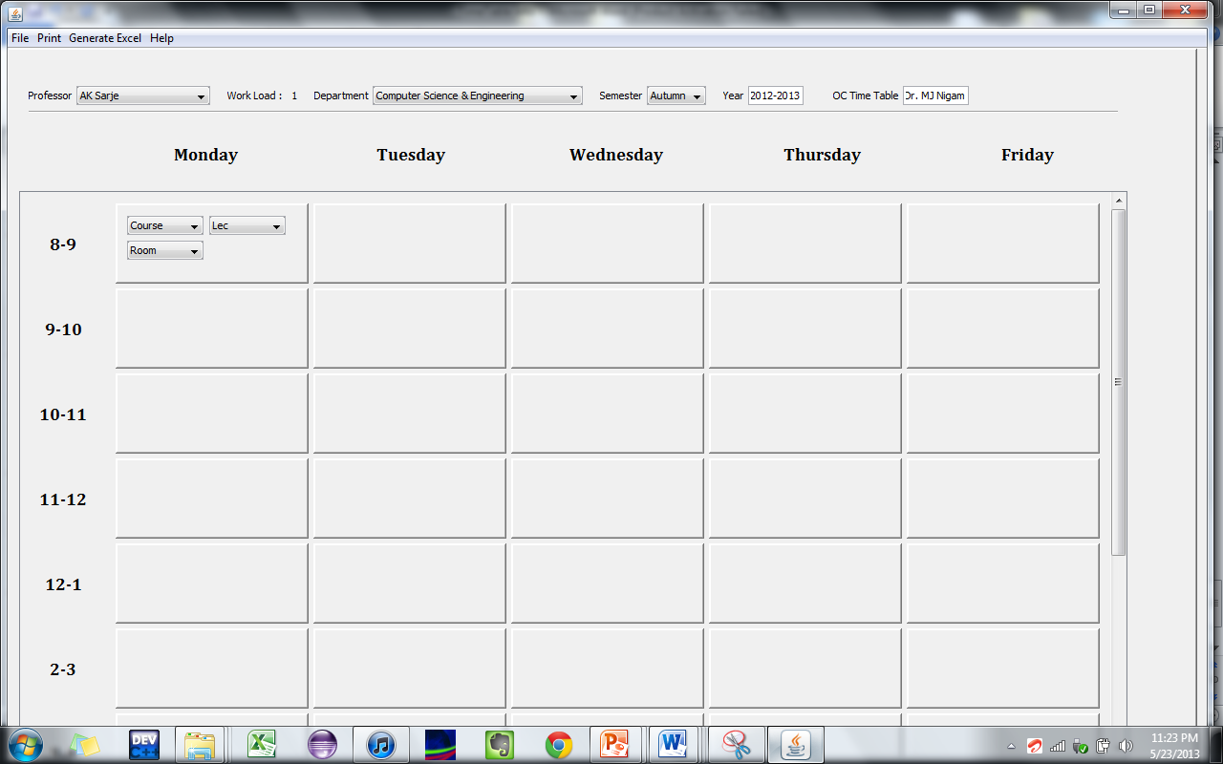

Now we can select a Course, Room, Lec/Tut/Prac from drop down lists.

So for example we have assigned EC 311 lecture class to be held in room W 203:

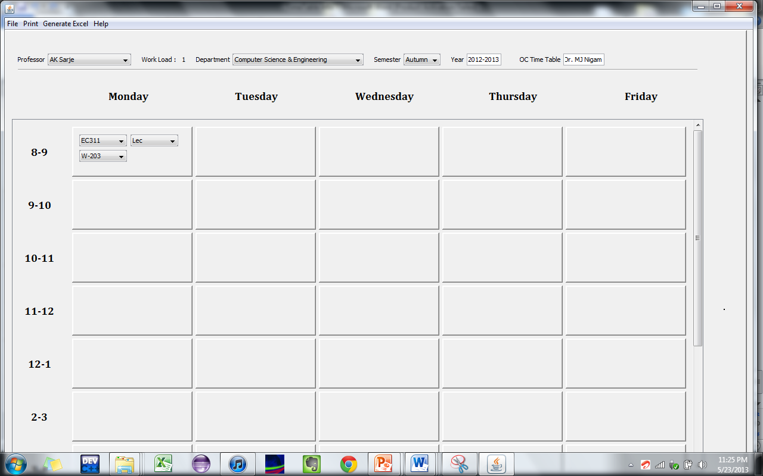

Similarly we can Enter values in other time slots as required. We can also use the feature of Drag and Drop.

If we want to delete any scheduled class, we simply click on the time slot and press Delete on keyboard.

Now suppose we schedule EC 301 class in same time slot for another professor, there will be a pop up telling about the student clashes that are there! That is listing the common students in EC 301 and another course who are already attending class in the same time slot.

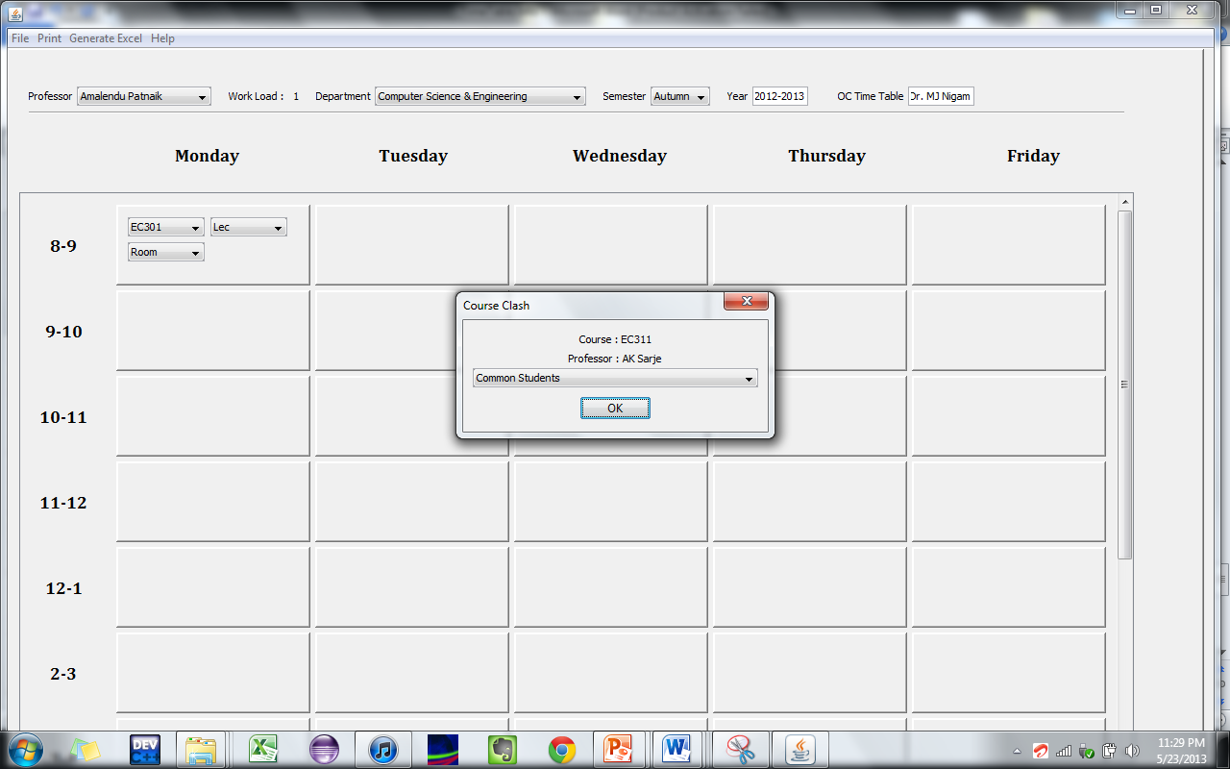

On seeing the clash we can reschedule the time table so as to avoid the clash.

Once the time table has been designed, we can either directly take print out of time table or save the time table in excel files.

As shown in the following figure, we can either take print out of professor currently selected or we can take the print out of time tables of all the professors.

Similarly we can save time tables in excel files either for the current professor or for all the professors.

Also as mentioned earlier, we can always save an incomplete time table using ‘Save’ option in file menu, and later open it using the ‘Open’ option. This way we can design the time table at our own pace.

